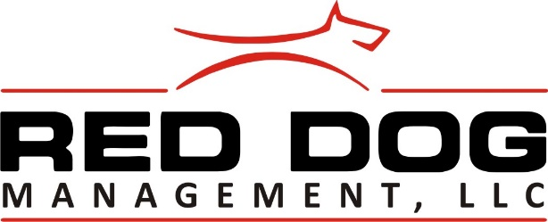

**EVICTION NOTICE**

**June 7, 2019**

Ms Amber Harris (Tenant)

300 Cherry Hill, Apt 7

North Little Rock, 72116

**TO TENANT(S) AND ALL OTHERS IN POSSESSION OF THE PREMISES LOCATED AT:** 300 Cherry Hill, Apt 7, North Little Rock AR, 72116

PLEASE TAKE NOTICE that you, Amber Harris, have violated the following term(s) in your signed lease and/or rental agreement dated 1 March, 2019:

(7) Utility Bills; Tenant Agrees to pay all utility bills incurred in connection with the occupancy of the leased premises.

(15) Default of Rent; Provided that in case any rent shall be due and unpaid after five (5) days, or if Tenant shall default in any of the covenants herein contained, or if said premises shall be abandoned, deserted or vacated, or if the Tenant shall become insolvent (defined here as inability to meet obligations as they become due, then it shall be lawful for the Management, its attorneys, successors, or assigns to re-enter and repossess said premise and evict, remove and put out Tenant and each and every occupant thereof, and upon re-entry, this lease shall terminate.

(28) No Smoking; Tenants, family members, friends or visitors will not be allowed to smoke within the apartments, lobby, and hallways, inside common areas of the complex or laundry facility.

**Use this letter as the official notice that you have until 10 June, 2019 to vacate the premise.**

**By the Arkansas Landlord/Tenant Law, “Unlawful Detainer Method of Eviction”, the landlord must provide at least (3 days notice) prior to civil eviction.**

You are hereby required to perform the aforesaid covenant(s) OR quit the subject premises, move out, and deliver up possession of the same to **RED DOG MANAGEMENT**. Failure to perform aforesaid covenant(s) OR vacate the premises NLT 5:00 pm, 10 June, 2019, as required by this notice, will result in forfeiture of the lease and /or rental agreement and will institute legal proceeding against you to recover rent, damages and possession of said premises.

“*THIS IS INTENDED AS THREE (3) DAY NOTICE FOR NONCOMPLIANCE OF THE LEASE THIS NOTICE IS IN ACCORDANCE WITH THE ARKANSAS RESIDENTIAL LANDLORD AND TENANT ACT 18-17-701. LANDLORD RESERVES ALL THE RIGHTS AND REMEDIES PROVIDED UNDER THE RENTAL AGREEMENT AND UNDER APPLICABLE LAWS OF THE STATE OF ARKANSAS INCLUDING BUT NOT LIMITED TO DAMAGES FOR UNPAID RENT OR PROPERTY AND NOTHING IN THIS NOTICE MAY BE CONSTRUED AS A WAIVER OF SUCH RIGHTS AND REMEDIES”.*

Dated: 7 June, 2019

By: _______________________________ Tenant (s): ______________________________

Red Dog Management, PO Box #7, Scott, AR 72142, 501-813-0051